141 Total miles - This route has a moderate pace, about 2.5 – 3.5 hours of cruising per day. It includes a flight of locks to and from Seneca Falls. There are some great stops along this route, with time for exploration, tours, museums, and shopping in Seneca Falls, Fairport, Palmyra, and Newark.

** See our Onboard Town Information Binder for town maps, menus, and attractions **

Leg Start (mile) - Leg Stop (mile) Leg Dist Time

Day 1 Hibiscus Harbor Marina – Seneca Falls 11.0 2+00
Locks: CS2, CS3 (Flight of 2 Locks) +45
Overnight at Seneca Falls, North Wall (P,W,S,L,P/O) Day 1 Total: 11.0 2+45

This is a very nice cruise Northward and Westward on a segment of the Cayuga Seneca canal. Please cruise slowly past all cottage docks, and mind your wake. The home and boat owners along the entire canal are always on the watch. You are responsible for any damage caused by your wake. We always slow down to a neighborly “no wake” speed (about 4.5 mph or less) when passing docked vessels. This stretch of the canal features a “flight of two locks” at CS 2/3. You will pass Van Cleef Lake, and the picturesque “Trinity Church”, have your camera ready. Then you will pass under Ovid Street Bridge and arrive in…

Seneca Falls - We recommend docking in Seneca Falls on the North side Canal Wall, where you will find power and water available free of charge, and a coin operated pump out station on the floating dock at the East end. There is a new “Boaters Amenities Facility” just West of the floating dock with Private Showers, Laundry, tour info, and vending machine drinks.

Code for the mens and womens showers at Seneca Falls is 2- 3 - 4

The North wall of the canal has power, and puts you close to all the restaurants, museums, and shops, which you can visit this evening, and in the morning. Seneca Falls is the home of the National Womens Rights Museum, and inspired Frank Capra’s film classic “It’s a Wonderful Life”, Starring Jimmy Stewart. Be sure to visit “The Clarence Hotel” at the corner of State and Falls Street, say hello to the staff for us, and enjoy an outstanding meal of all fresh in house prepared entrees, salads, tapas, and desserts….this is a favorite of ours !! Other favorites include ZuZu’s, The Downtown Deli, Parkers Bar and Grille and for breakfast Jeremy’s Café…which has 99 cent breakfast, hot coffee, and a full menu…

You can find Ice and necessaries at Byrne Dairy on Fall Street, just a block West of the Park.

Day 2 Seneca Falls - Clyde 19.0 2+45
Locks: CS2/3, CS1, E-25, E-26 1+15
Overnight @ Clyde Town Dock (P, W) Day 2 Total: 19.0 4+00

With about 4 hours of cruising ahead today, you can sleep in, or rise early and enjoy breakfast at Jeremy’s, a local favorite with a back entrance facing the canal, just to the right of the boaters facility entrance. You could do some touring, and then have ZuZu’sor the Downtown Deli make you a beautiful lunch that you could eat while underway. ICE is available at Byrne Dairy, a block West of Jeremy’s.
You’ll head back Eastward, past Trinity Church, Van Cleef Lake, and locks CS 2/3. Tell them you are heading through lock CS 1 and they will notify that lock of your intentions as soon as you are on your way out of lock CS2. You’ll see those quaint cottages again, (remember NO WAKE), and then you’ll proceed North through lock CS1. See how easy that was since you had the lockmaster at CS2/3 call ahead for you? Cruise about 4 North miles then bear off to Port (left) at the intersection, (triangular island), of the Cayuga Seneca & Erie Canal. This is well marked on your Cruising Guide. Call lock E25 on channel 13, and let them know your intention to transit lock E25 Westward to Clyde… it’s an easy 4 miles to the….

The Village of Clyde, which has just added power and water to their village dock, on the South side of the canal. Dock here tonight. You could call ahead to double J’s Pizza and have dinner delivered to the dock. A short walk over the Glasgow St (Rte 414) Bridge to the North will put you in the middle of town. If you need to do any shopping there is a FastTrack gas station and convenience store in town. Take along our “pack and roll” cart to bring back any items you may need in Clyde. There are some fine family dining restaurants here, try Bistro 12 which is open Mon – Sat 11 – 8, The Brick Oven has breakfast and lunch, 8 am – 2 pm…but not dinner. For Pizza and Sandwiches try Double J’s Pizzeria, they will deliver to the dock. There is a liquor store,& pharmacy in town as well.

You only have about a 3 hour cruise today, so enjoy Clyde, the Galen Museum, and some of the unusual architecture in this town. For breakfast Brick Oven is the choice, (see above) they will make a lunch to go for your cruise today as well….remember they are open 8 am – 2 pm only.

Day 3 Clyde - Newark 15.0 2+15
Locks E-27, E-28A, E28B (P, W, S, L, P/O) 0+45
O/N in Newark @ T.Spencer Knight Canal Port Day 3 Total: 15.0 3+00

From Clyde it’s 12 miles to Lyons, which has a nice dock on the North wall, and a number of sights to see if you want to stretch your legs. Call each lock on Ch 13 when you are about 15 minutes out, and let them know your proposed destination for the day.

We occasionally enjoy lunch under a shady tree at the American Legion in Lyons. Showers are available at the Fire Station, which is just up the bank from the dock, next to the American Legion Hall. The firemen are eager to assist cruisers with all questions about their town. After your stop in Lyons, it’s only 5 miles to Newark.
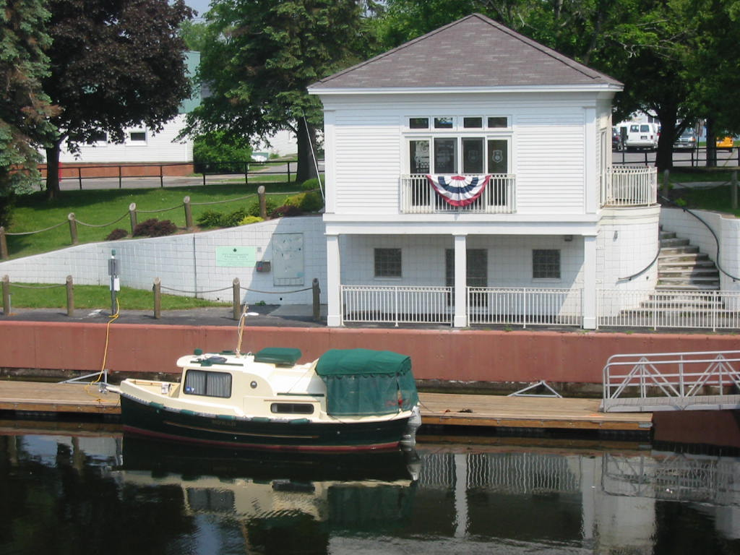
Newark- is another of our favorite stops, and the Nomad is well known at the T. Spencer Knight Canal Port. We usually dock on the floating dock just West of the East Ave Bridge. This is just below the new Canal dockmasters facility. See picture below/left. Walk up stairs to get a key for the restrooms, showers, Laundry, facilities, which are downstairs, and free to cruisers. Visit with the “Dockmaster on duty”, for his/her in town recommendations. He/She will assist you with 30 amp power connections which are on the wall next to the floating dock. Secure boat end of cord first, then use your boathook to hand cord to dockmaster or your crew on the wall. Then plug your cord in to 30 amp power outlet with a wrap or two around pole.

We always plan to have Breakfast at the Newark Diner, Walk South over the East Ave Bridge, and then a couple of blocks East along Rte 31. Just a little further East from the diner, is GettyMart, a convenience store for ICE, drinks etc. There are a number of dining options in Newark, just ask the dockmaster, or any of the other cruisers tied up here. See our binder for numerous dining, movie, shopping options….

Day 4 Newark - Fairport 21.0 3+00
Locks: E-29, E-30 (P, W, S, L,) +30
O/N Fairport Town Wall, North or South ($6) Day 4 Total: 21.0 3+30

NOTE: Consider whether to Pump Out before leaving Newark. You may want to make a short stop in Newark on your return trip to Pump Out at as well. Their coin op. facility is under the bridge, just to the right of the picture above
.
Today you’ll enjoy 21 miles of the canal on the way to Fairport. Plan for about 3 and a half hours.

As you pass Mark G721 you enter an area known as “Widewaters”, stay to the North side of the canal and follow the channel markers to avoid shallows along the south side of this section. Note the new Marina in Palmyra as it passes off the Port side between Marks G767 and G769. This brand new port makes for a nice lunch stop, and it will be an overnight stop on your way Eastward in a few days. Stop and have lunch here, or just slow down and take a look on your way by. About 5 miles to the West, after passing locks E29 and E30, near Mark G795, and just West of the Canandaigua Bridge, you’ll see….

Mid Lakes Macedon Marina. This is a very nice full service marina, and has fuel, pump out, shower and laundry facilities. Plan a stop here on your way East to refuel at the small inlet on the West side of the main marina.
After passing Mark R810, there are no more numbered buoys, or markers on the canal system to the West. The canal is easy to follow, just stay toward the center, unless passing other vessels. From Mark R810 you have about 4.5 miles to Fairport, and the North Bank Park.

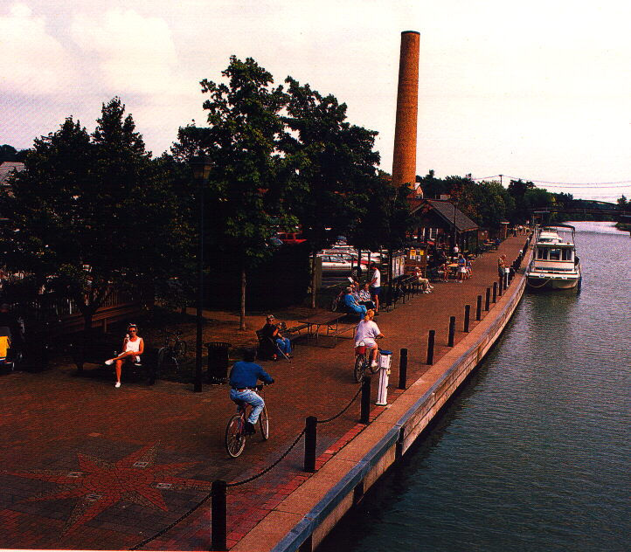
Fairport- is another fantastic town on the canal system. Their Facilities are probably some of the finest we’ve seen for cruisers in any setting. We usually dock on the North Side, as it is closest to our favorite restaurants and pub. See picture to the left, (photo is taken from liftbridge facing East). You’ll find 30 amp power, and water. The dockmaster can be reached after 5 pm on ch 13 VHF, if not available, talk to the lift bridge operator on the same channel. Either can give you the current combo to the restrooms, showers etc. There is a $6 per night fee that can be paid at the dockmaster’s office, which is on the South wall, in a small Gabebo shaped building. The restrooms, which feature 4 private “suites”, each include a vanity/sink, toilet, and shower. Basically each is a private bathroom with its own locking door for privacy. These facilities are just over the Parker Street bridge, then about 200 yds to the right, in the lower level of a small office building. There are also restrooms on the North Side, in the lobby of the building where “Scoops” Ice Cream shop is located.

We always stop in at Donnelly’s Pub, just across the street from “the Box Factory” building, only a few steps North from your dock if you’re on the North side. They have a full bar, a dozen draft beers, and a nice pub menu for lunch and dinner. I particularly like the Guinness Marinated Pulled Pork Sandwich…but everything we’ve tried, we liked. If you feel like Pizza, there is a Pizza shop right next door to Donnelly’s. Something a bit more “al Fresco”, try the Liftbridge Café, canalside dining, just a few yards ahead of your boat, it would be just to the left of the picture above. They have a covered patio, where you can enjoy dinner, full bar service, and watch all the passersby stop and look at “your boat”.

For breakfast, it has to be Riki’s Cafe, the whole town turns out here. It’s North about 1 block on Main St. (same street as the lift bridge), on the West side of the Street. They have a very complete breakfast, and lunch menu, in true diner style, I like the omlettes, and they have some very good greek specialties as well.

There is a very nice Wine Shop just South over the lift bridge, on the West side, in a shopping center, You’ll also find a fine Butcher Shop, Dollar General Store, and the local library too…
ICE is available at the “Colonial Belle” gift shop not far from the dockmasters office for $1.50 a bag.

Day 5 Fairport – Pittsford (lunch, shopping) 7.5 1+00
Pittsford – Palmyra (arrive before sundown) 19.0 2+45
Locks: E30, E29, 0+30
O/N @ Palmyra Marina, new facility (P, W, P/O) Day 5 Total: 26.5 4+15

Before heading WEST, Call Ch 13 to raise the Fairport Lift Bridge , for Nomad’s Mast/Antenna

Consider a leisurely cruise West to Pittsford for an early lunch today. Pittsford is equally as pleasant as Fairport, but there is no power available for staying overnight. Try Aladdin’s on the North side wall at Schoen Place, they are famous for delicious Pita Wraps, Greek Salads, Hummus etc. You could try The Crepe Shop across from Aladdin’s is also very good. See our onboard Town Guide book for more info.

After lunch in Pittsford, you begin to work your way back to the East past Fairport, have the Fairport bridge raised once again to clear Nomad’s Mast and antenna….then you are on your way to Palmyra.
This is all familiar cruising grounds to you now, so relax and enjoy the scenery. Toot your horn for kids on their bikes, and wave at folks driving along Hwy 31 who are a bit jealous that they aren’t cruising too.

Just East of Mark G797 on the South side of the canal you will again see Mid-Lakes Macedon Marina. This is a full service marina, and we recommend you check your fuel status before passing up this convenient stop. (Next fuel stop is near lock E27 at Millers Marine about 18 miles East). There is a channel on the West side of the Macedon marina that goes to the fuel and pump out facility. You may see some of Mid-Lakes European “barge style” canal boats on this dock. The Wiles family (owners) and their Staff will be glad to help you with fuel and any other services. If you need anything, just ask. ICE, Drinks, and snacks are available. The main marina entrance is about 500 yds. East of the fuel/service dock.
Please Refer to…. “Refueling Checklist” in NOMAD’s Ops Manual.

After you have topped off your fuel, and emptied your holding tank if needed, it’s a short cruise to….

Palmyra Marina - is located just after passing under the Division St. Bridge, at Mark G769, on the South Side of the canal. There is 30 amp power, water, and a free Pump Out station.
There are some beautiful homes in Palmyra, and on the corner of Rte 31 and Rte 21 there are four unique churches, one on each corner. Palmyra is also the original home of the Mormon Church, and its founder John Smith. There is an annual Hill Cumorah Mormon pageant, set in an outdoor amphitheatre.
There is a new restaurant at the West end of the dock you could try, and a number of others in town, see our guide, for options here in Palmyra.

Day 6 Palmyra - Clyde 23.0 3+15
Locks: E28B, E28A, E27 +45
O/N @ Clyde Village Dock, (P, W,) Day 6 Total: 23.0 4+00

You could stop in Newark, or Lyons, have lunch, and then continue toward Clyde. For dinner in Clyde try “Bistro 12”, open 11-8 (Closed Sunday).

Day 7 Clyde – Hibiscus Harbor Marina 15.0 2+00 Locks: E26, E25, CS1 +45
O/N @ Hibiscus Harbor Marina (P,W,S,L,F, P/O), Day 7 Total: 15.0 2+45
Pump Out, and refuel on your way in to the marina, then tie her up at slip #125. Plug in your power cord, fill up the water tank, turn on the A/C and begin to tidy up the Nomad, and unload some of your gear.

You could have dinner at the Wheel House at the marina, or take advantage of using your car to try Suzanne’s French Restaurant in Lodi, NY, one of my father’s favorites in the region.…or Wolfie’s on the West Shore of Cayuga Lake with a shore side deck, facing East with a great view.

Day 8 – @ Hibiscus Harbor - You can sleep in and finish your unpacking, and light tidying up to hand the Nomad over the Mark and Holly at 10 am.

Day 7 OPTION: Clyde to Seneca Falls 13.0 1+50
Locks E26, E25, CS1, CS2/3 1+15
Day 7 Total: 13.0 3+05

Day 8 OPTION - Seneca Falls – Cayuga Marina & Camp. 9.0 1+30
Locks: CS2/3 +30
Day 8 Total: 9.0 2+00
NOTE: Depart Seneca Falls NLT 0730 to arrive at Hibiscus Harbor Marina and allow time to stop at eh pump out dock, then motor across to the fuel dock, and refuel, then return to slip #125. Off load and tidy up Nomad by 10 am handover to Mark and Holly.

Trip Total Distance: 132 / 141

