Planning, and Dreaming about your adventure….

The Cruising Guide to the New York State Canal System –

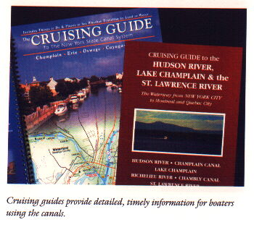
This is the most valuable planning and tool available to all canal cruisers.
We suggest that our charter guests purchase a personal copy of “The Cruising Guide to the New York State Canal System”, as it is the definitive source of information on the NYS Canal system.

Visit www.canals.state.ny.us to order your copy as soon as you reserve your cruise. It’s great for planning and organizing your vacation. It also makes a terrific way to share your canal adventure with your family and friends, both prior to, and after your cruise. Phone numbers for all the marinas, locks, and attended town docks are listed in “The Cruising Guide”. There’s a copy onboard for your use, and fellow cruisers have made copious notes on its pages for your benefit.

Charts, mile markers, and “cruising speed”…

Your Nimble Nomad cruises at 7 mph. The mile markers in The Cruising Guide and in our suggested itineraries are also in miles. This makes using one of our routes, or planning one yourself very easy. Our plans allow about 10 - 15 minutes for each lock you transit. Note: Times listed in the Cruising Guide are based on 10 mph, a bit faster than.

Fuel Usage, or “the lack of fuel usage…”

The Nomads 50 hp Honda uses about 0.75 gal/hr.,@ 2200 – 2500 rpm. It has a 23 gallon tank. Just note the engine hour meter each time you fill the tank. Probably once In a week. Figure one gallon per hour of engine time, which is very conservative. This makes fuel calculation simple, conservative, and safe. Refuel about the 15-18 hr point.
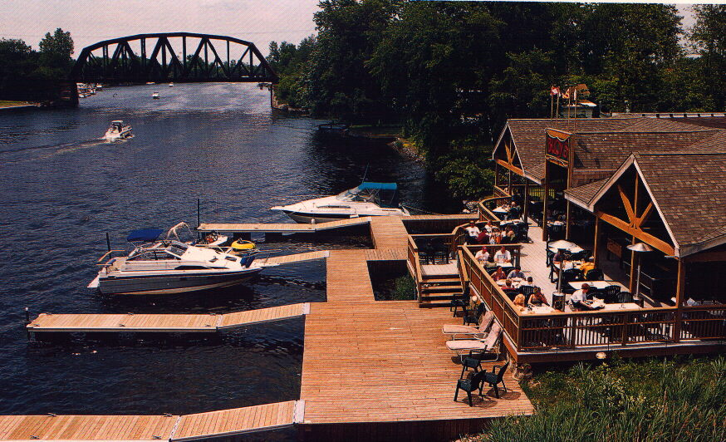
Most Marinas close at 5 pm. Call ahead, as early as possible, to make marina reservations, and verify that the services you desire will be available upon your arrival. For a late arrival, ask for specific slip number and location in the marina.
Marinas charge about $1.50/ft./night ($36) for the 24 ft. Nomad. Consult The Cruising Guide for marina phone numbers, and for information about each of their hours, available services, and fees.

We recommend staying at the town walls or lock walls. Their name doesn’t do them justice. Most locations have 30 amp shore power, and many have restrooms and showers as well. They are usually free to guests, or have a very nominal charge. Our charter customers have commented that these are some of the nicest facilities they’ve ever seen. Lock Walls and their facilities are “always open” and the lockmasters are a great source of local information, and recommendations for each of their towns.

How do you get “the good spots” on the town walls, or at marinas and lock walls?
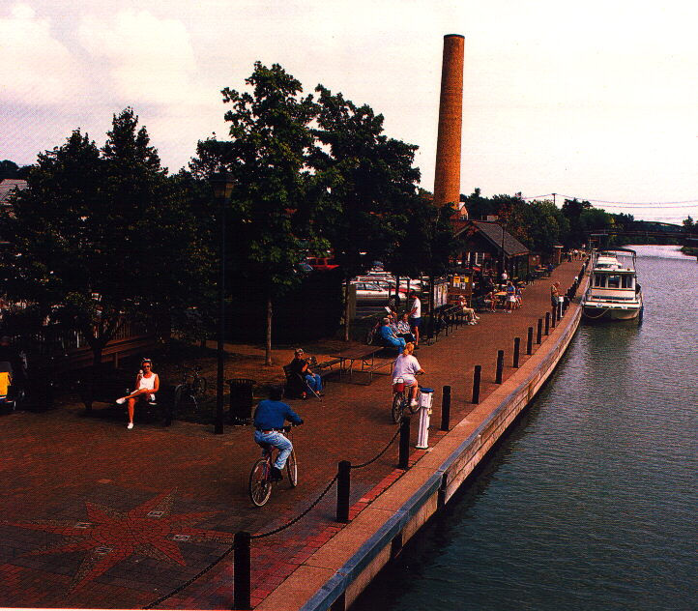
Get there early. It is often more difficult to acquire a good spot if you arrive later in the day. Cruisers are a very sociable group, and if you need assistance with docking, making room for your vessel, or even to borrow additional water hose, or power cord, just ask. Other boaters are eager to assist you, and want you to have a great cruise.

Most restaurants, pubs, markets and stores are open until 9 pm, along the canal. Some stay open later on weekends, especially those near our recommended overnight locations.

Provisions/Shopping –
It is common to “over provision”, we urge you not to fall into this trap. There are plenty of markets along the canal, and they make a fine way to enjoy some local specialties. The Nomad has a 36 qt. cooler, and a small undercounte marine 12v/110v refrigerator.

Markets - We’ve never had difficulty finding ice, drinks, snacks, and basic groceries in many of the towns we visit. Some true “gourmet” shopping.

We usually shop for about three (3) days worth of breakfast and lunch, along with some snacks and drinks and one/two nice dinners aboard. After three days, we evaluate our stores, and restock as needed at town markets along the way. For those unfamiliar with Wegmans markets, you are in for a treat. In Aurora, 15 minutes from the Cayuga Marina, Wegmans has a gourmet super market, which includes a Deli, Bakery ,& Wine shop. There is also a Super Wal Mart, for any other needs you may have.

Breakfast: We usually make breakfast aboard; but occasionally enjoy a local diner near the canal when available. It’s easy to make coffee, enjoy a bagel, danish, or croissants with some fruit and jam. We occasionally include Mimosa’s! This meal is easiest to prepare while still connected to “shore power” with electrical service, for coffee/tea and the Microwave. We use the gas grill on the aft deck for eggs, bacon, omlettes.

Lunch: We buy enough deli meats, bread, lettuce, cheese and condiments for 3 – 4 days of lunches. Some chips, nuts, cookies, and fruit are also great accompaniments. Sometimes if we’re on a particularly long leg, we eat while cruising, and other imes we stop and have lunch at canal parks, locks, or restaurants, then continue on our way.

Dinner: Normally we frequent the great restaurants along our journey. There are so many good ones to choose from. From truly “fine dining” to fun local pubs and pizzerias, they provide wonderful meals, they do the dishes, and afterward we retire to the trawler for a “night cap” or decadent sweet. Occasionally we’ll grill steaks, or fresh local fish, open a ready made salad with dressing, add some fresh veggies to grill or “foil steam”. This makes for a very impressive and easy to prepare meal. Add a glass of your favorite New York wine if you like, and you’ll be the envy of the anchorage.
Packing for your adventure…

DON’T OVERPACK, Soft luggage that can be easily stored in the Nomads “out of the way cubbies” are the way to go. There’s not a single place we have been on the canal system that casual and comfortable attire wasn’t acceptable. Comfortable boat shoes, or non marring sneakers are best for on shore activities, we go barefoot, or in our socks when aboard. Shirts with a collar, shorts / jeans / khakis and a light jacket are all you need…

We use duffle bags, about 10” x 10” x 24” that are available at WalMart, Target, or Sporting Goods stores. If you travel with hard sided luggage, you might consider bringing along a couple of these soft duffles. Then “repack”, and store your big suitcases at the Marina. It’s always better if you don’t have to move big suitcases around the Nomad all week. Smaller is better.

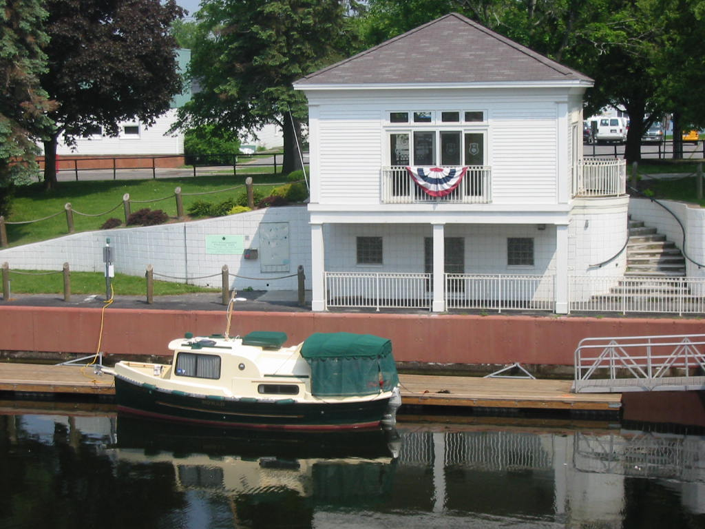
Laundry facilities are available in many towns, close to the town walls and marinas. This is the Cruisers’ restrooms, showers, and laundry facilities in Newark. These are usually coin operated, or FREE. Just buy a small box of soap, and do your laundry while relaxing canalside with that great Cabernet and a beautiful sunset…

